21. Write a C program for ECB, CBC, and CFB modes, the plaintext must be a sequence of one or more complete data blocks (or, for CFB mode, data segments). In other words, for these three modes, the total number of bits in the plaintext must be a positive multiple of the block (or segment) size. One common method of padding, if needed, consists of a 1 bit followed by as few zero bits, possibly none, as are necessary to complete the final block. It is considered good practice for the sender to pad every message, including messages in which the final message block is already complete. What is the motivation for including a padding block when padding is not needed?

#include <stdio.h>

#include <string.h>

#define BLOCK_SIZE 8

void xor_encrypt(unsigned char *block, unsigned char *key) {

for (int i = 0; i < BLOCK_SIZE; i++) {

block[i] ^= key[i];

}

}

void xor_blocks(unsigned char *out, unsigned char *a, unsigned char *b) {

for (int i = 0; i < BLOCK_SIZE; i++) {

out[i] = a[i] ^ b[i];

}

}

int pad(unsigned char *input, int len) {

int pad_len = BLOCK_SIZE - (len % BLOCK_SIZE);

input[len] = 0x80;

for (int i = 1; i < pad_len; i++)

input[len + i] = 0x00;

return len + pad_len;

}

void print_hex(const char *label, unsigned char *data, int len) {

printf("%s: ", label);

for (int i = 0; i < len; i++) printf("%02x", data[i]);

printf("\n");

}

int main() {

unsigned char key[BLOCK_SIZE] = "mysecret";

unsigned char iv[BLOCK_SIZE] = "initvect";

unsigned char plaintext[64] = "This is a test of ECB, CBC, and CFB modes.";

unsigned char padded[80];

unsigned char ecb[80], cbc[80], cfb[80];

unsigned char block[BLOCK_SIZE];

int len = strlen((char *)plaintext);

memcpy(padded, plaintext, len);

int padded_len = pad(padded, len);

printf("Plaintext (padded): %s\n", padded);

for (int i = 0; i < padded_len; i += BLOCK_SIZE) {

memcpy(block, &padded[i], BLOCK_SIZE);

xor_encrypt(block, key);

memcpy(&ecb[i], block, BLOCK_SIZE);

}

unsigned char prev[BLOCK_SIZE];

memcpy(prev, iv, BLOCK_SIZE);

for (int i = 0; i < padded_len; i += BLOCK_SIZE) {

xor_blocks(block, &padded[i], prev);

xor_encrypt(block, key);

memcpy(&cbc[i], block, BLOCK_SIZE);

memcpy(prev, block, BLOCK_SIZE);

}

memcpy(prev, iv, BLOCK_SIZE);

for (int i = 0; i < padded_len; i += BLOCK_SIZE) {

memcpy(block, prev, BLOCK_SIZE);

xor_encrypt(block, key);

xor_blocks(&cfb[i], &padded[i], block);

memcpy(prev, &cfb[i], BLOCK_SIZE);

}

print_hex("ECB Mode Cipher", ecb, padded_len);

print_hex("CBC Mode Cipher", cbc, padded_len);

print_hex("CFB Mode Cipher", cfb, padded_len);

return 0;

}

OUTPUT:

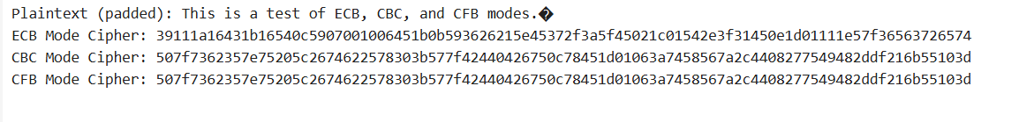

22. Write a C program for Encrypt and decrypt in cipher block chaining mode using one of the following ciphers: affine modulo 256, Hill modulo 256, S-DES, DES. Test data for S-DES using a binary initialization vector of 1010 1010. A binary plaintext of 0000 0001 0010 0011 encrypted with a binary key of 01111 11101 should give a binary plaintext of 1111 0100 0000 1011. Decryption should work correspondingly.

#include <stdio.h>

#include <stdint.h>

uint8_t IP[] = {1, 5, 2, 0, 3, 7, 4, 6};

uint8_t IP_INV[] = {3, 0, 2, 4, 6, 1, 7, 5};

uint8_t EP[] = {3, 0, 1, 2, 1, 2, 3, 0};

uint8_t P4[] = {1, 3, 2, 0};

uint8_t P10[] = {2, 4, 1, 6, 3, 9, 0, 8, 7, 5};

uint8_t P8[] = {5, 2, 6, 3, 7, 4, 9, 8};

uint8_t S0[4][4] = {

{1, 0, 3, 2},

{3, 2, 1, 0},

{0, 2, 1, 3},

{3, 1, 3, 2}

};

uint8_t S1[4][4] = {

{0, 1, 2, 3},

{2, 0, 1, 3},

{3, 0, 1, 0},

{2, 1, 0, 3}

};

uint8_t permute(uint8_t in, uint8_t* p, int n) {

uint8_t out = 0;

for (int i = 0; i < n; i++) {

out <<= 1;

out |= (in >> (7 - p[i])) & 1;

}

return out;

}

uint8_t leftShift5(uint8_t in, int shifts) {

return ((in << shifts) | (in >> (5 - shifts))) & 0x1F;

}

uint16_t keyGen(uint16_t key, uint8_t* k1, uint8_t* k2) {

uint16_t perm = 0;

for (int i = 0; i < 10; i++) {

perm <<= 1;

perm |= (key >> (9 - P10[i])) & 1;

}

uint8_t left = (perm >> 5) & 0x1F;

uint8_t right = perm & 0x1F;

left = leftShift5(left, 1);

right = leftShift5(right, 1);

uint16_t merged = (left << 5) | right;

*k1 = 0;

for (int i = 0; i < 8; i++) {

*k1 <<= 1;

*k1 |= (merged >> (9 - P8[i])) & 1;

}

left = leftShift5(left, 2);

right = leftShift5(right, 2);

merged = (left << 5) | right;

*k2 = 0;

for (int i = 0; i < 8; i++) {

*k2 <<= 1;

*k2 |= (merged >> (9 - P8[i])) & 1;

}

return 0;

}

uint8_t sbox(uint8_t in, uint8_t box[4][4]) {

uint8_t row = ((in & 0x8) >> 2) | (in & 0x1);

uint8_t col = (in >> 1) & 0x3;

return box[row][col];

}

uint8_t f(uint8_t r, uint8_t sk) {

uint8_t ep = 0;

for (int i = 0; i < 8; i++) {

ep <<= 1;

ep |= (r >> (3 - EP[i])) & 1;

}

uint8_t x = ep ^ sk;

uint8_t left = (x >> 4) & 0xF;

uint8_t right = x & 0xF;

uint8_t out = (sbox(left, S0) << 2) | sbox(right, S1);

uint8_t p4out = 0;

for (int i = 0; i < 4; i++) {

p4out <<= 1;

p4out |= (out >> (3 - P4[i])) & 1;

}

return p4out;

}

uint8_t fk(uint8_t in, uint8_t k1, uint8_t k2, int isDecrypt) {

uint8_t ip = permute(in, IP, 8);

uint8_t left = ip >> 4;

uint8_t right = ip & 0xF;

uint8_t t1 = f(right, isDecrypt ? k2 : k1);

left ^= t1;

uint8_t swapped = (right << 4) | left;

right = swapped & 0xF;

left = swapped >> 4;

uint8_t t2 = f(right, isDecrypt ? k1 : k2);

left ^= t2;

uint8_t preout = (left << 4) | right;

uint8_t out = permute(preout, IP_INV, 8);

return out;

}

void encryptCBC(uint8_t* pt, uint8_t* ct, int n, uint8_t k1, uint8_t k2, uint8_t iv) {

uint8_t prev = iv;

for (int i = 0; i < n; i++) {

uint8_t block = pt[i] ^ prev;

ct[i] = fk(block, k1, k2, 0);

prev = ct[i];

}

}

void decryptCBC(uint8_t* ct, uint8_t* pt, int n, uint8_t k1, uint8_t k2, uint8_t iv) {

uint8_t prev = iv;

for (int i = 0; i < n; i++) {

uint8_t temp = fk(ct[i], k1, k2, 1);

pt[i] = temp ^ prev;

prev = ct[i];

}

}

int main() {

uint8_t plaintext[2] = {0x01, 0x23};

uint8_t ciphertext[2], decrypted[2];

uint8_t iv = 0xAA;

uint8_t k1, k2;

uint16_t key = 0x1FD;

keyGen(key, &k1, &k2);

encryptCBC(plaintext, ciphertext, 2, k1, k2, iv);

printf("Encrypted: %02X %02X\n", ciphertext[0], ciphertext[1]);

decryptCBC(ciphertext, decrypted, 2, k1, k2, iv);

printf("Decrypted: %02X %02X\n", decrypted[0], decrypted[1]);

return 0;

}

OUTPUT:

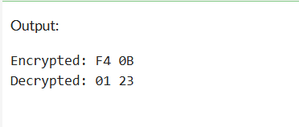

23. Write a C program for Encrypt and decrypt in counter mode using one of the following ciphers: affine modulo 256, Hill modulo 256, S-DES. Test data for S-DES using a counter starting at 0000 0000. A binary plaintext of 0000 0001 0000 0010 0000 0100 encrypted with a binary key of 01111 11101 should give a binary plaintext of 0011 1000 0100 1111 0011 0010. Decryption should work correspondingly.

#include <stdio.h>

#include <stdint.h>

uint8_t IP[] = {1, 5, 2, 0, 3, 7, 4, 6};

uint8_t IP_INV[] = {3, 0, 2, 4, 6, 1, 7, 5};

uint8_t EP[] = {3, 0, 1, 2, 1, 2, 3, 0};

uint8_t P4[] = {1, 3, 2, 0};

uint8_t P10[] = {2, 4, 1, 6, 3, 9, 0, 8, 7, 5};

uint8_t P8[] = {5, 2, 6, 3, 7, 4, 9, 8};

uint8_t S0[4][4] = {

{1, 0, 3, 2},

{3, 2, 1, 0},

{0, 2, 1, 3},

{3, 1, 3, 2}

};

uint8_t S1[4][4] = {

{0, 1, 2, 3},

{2, 0, 1, 3},

{3, 0, 1, 0},

{2, 1, 0, 3}

};

uint8_t permute(uint8_t in, uint8_t* p, int n) {

uint8_t out = 0;

for (int i = 0; i < n; i++) {

out <<= 1;

out |= (in >> (7 - p[i])) & 1;

}

return out;

}

uint8_t leftShift5(uint8_t in, int shifts) {

return ((in << shifts) | (in >> (5 - shifts))) & 0x1F;

}

void keyGen(uint16_t key, uint8_t* k1, uint8_t* k2) {

uint16_t perm = 0;

for (int i = 0; i < 10; i++) {

perm <<= 1;

perm |= (key >> (9 - P10[i])) & 1;

}

uint8_t left = (perm >> 5) & 0x1F;

uint8_t right = perm & 0x1F;

left = leftShift5(left, 1);

right = leftShift5(right, 1);

uint16_t merged = (left << 5) | right;

*k1 = 0;

for (int i = 0; i < 8; i++) {

*k1 <<= 1;

*k1 |= (merged >> (9 - P8[i])) & 1;

}

left = leftShift5(left, 2);

right = leftShift5(right, 2);

merged = (left << 5) | right;

*k2 = 0;

for (int i = 0; i < 8; i++) {

*k2 <<= 1;

*k2 |= (merged >> (9 - P8[i])) & 1;

}

}

uint8_t sbox(uint8_t in, uint8_t box[4][4]) {

uint8_t row = ((in & 0x8) >> 2) | (in & 0x1);

uint8_t col = (in >> 1) & 0x3;

return box[row][col];

}

uint8_t f(uint8_t r, uint8_t sk) {

uint8_t ep = 0;

for (int i = 0; i < 8; i++) {

ep <<= 1;

ep |= (r >> (3 - EP[i])) & 1;

}

uint8_t x = ep ^ sk;

uint8_t left = (x >> 4) & 0xF;

uint8_t right = x & 0xF;

uint8_t out = (sbox(left, S0) << 2) | sbox(right, S1);

uint8_t p4out = 0;

for (int i = 0; i < 4; i++) {

p4out <<= 1;

p4out |= (out >> (3 - P4[i])) & 1;

}

return p4out;

}

uint8_t fk(uint8_t in, uint8_t k1, uint8_t k2) {

uint8_t ip = permute(in, IP, 8);

uint8_t left = ip >> 4;

uint8_t right = ip & 0xF;

uint8_t t1 = f(right, k1);

left ^= t1;

uint8_t swapped = (right << 4) | left;

right = swapped & 0xF;

left = swapped >> 4;

uint8_t t2 = f(right, k2);

left ^= t2;

uint8_t preout = (left << 4) | right;

uint8_t out = permute(preout, IP_INV, 8);

return out;

}

void ctrMode(uint8_t* input, uint8_t* output, int n, uint8_t k1, uint8_t k2, uint8_t counterStart) {

for (int i = 0; i < n; i++) {

uint8_t keystream = fk(counterStart + i, k1, k2);

output[i] = input[i] ^ keystream;

}

}

int main() {

uint8_t plaintext[3] = {0x01, 0x02, 0x04};

uint8_t ciphertext[3], decrypted[3];

uint8_t k1, k2;

uint16_t key = 0x1FD;

uint8_t counter = 0x00;

keyGen(key, &k1, &k2);

ctrMode(plaintext, ciphertext, 3, k1, k2, counter);

printf("Encrypted: %02X %02X %02X\n", ciphertext[0], ciphertext[1], ciphertext[2]);

ctrMode(ciphertext, decrypted, 3, k1, k2, counter);

printf("Decrypted: %02X %02X %02X\n", decrypted[0], decrypted[1], decrypted[2]);

return 0;

}

OUTPUT:

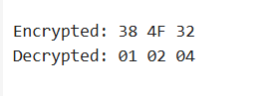

24. Write a C program for RSA system, the public key of a given user is e = 31, n = 3599. What is the private key of this user? Hint: First use trial-and-error to determine p and q; then use the extended Euclidean algorithm to find the multiplicative inverse of 31 modulo f(n).

#include <stdio.h>

int gcdExtended(int a, int b, int* x, int* y) {

if (a == 0) {

*x = 0;

*y = 1;

return b;

}

int x1, y1;

int gcd = gcdExtended(b % a, a, &x1, &y1);

*x = y1 - (b / a) * x1;

*y = x1;

return gcd;

}

int modInverse(int e, int phi) {

int x, y;

int g = gcdExtended(e, phi, &x, &y);

if (g != 1)

return -1;

else

return (x % phi + phi) % phi;

}

int main() {

int e = 31;

int n = 3599;

int p = 59, q = 61;

int phi = (p - 1) * (q - 1);

int d = modInverse(e, phi);

printf("Public Key (e, n): (%d, %d)\n", e, n);

printf("p = %d, q = %d\n", p, q);

printf("φ(n) = %d\n", phi);

printf("Private Key d = %d\n", d);

return 0;

}

OUTPUT:

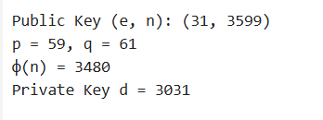

25. Write a C program for set of blocks encoded with the RSA algorithm and we don’t have the private key. Assume n = pq, e is the public key. Suppose also someone tells us they know one of the plaintext blocks has a common factor with n. Does this help us in any way?

#include <stdio.h>

int gcd(int a, int b) {

while (b != 0) {

int temp = b;

b = a % b;

a = temp;

}

return a;

}

int gcdExtended(int a, int b, int* x, int* y) {

if (a == 0) {

*x = 0;

*y = 1;

return b;

}

int x1, y1;

int gcd = gcdExtended(b % a, a, &x1, &y1);

*x = y1 - (b / a) * x1;

*y = x1;

return gcd;

}

int modInverse(int e, int phi) {

int x, y;

int g = gcdExtended(e, phi, &x, &y);

if (g != 1)

return -1;

else

return (x % phi + phi) % phi;

}

int main() {

int n = 3599;

int e = 31;

int known_plaintext = 122;

int factor = gcd(known_plaintext, n);

if (factor == 1 || factor == n) {

printf("No useful factor found.\n");

return 0;

}

int p = factor;

int q = n / p;

printf("Found factors: p = %d, q = %d\n", p, q);

int phi = (p - 1) * (q - 1);

int d = modInverse(e, phi);

printf("φ(n) = %d\n", phi);

printf("Private key d = %d\n", d);

return 0;

}

OUTPUT:

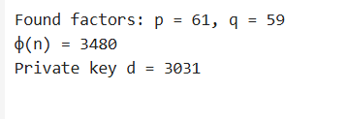

26. Write a C program for RSA public-key encryption scheme, each user has a public key, e, and a private key, d. Suppose Bob leaks his private key. Rather than generating a new modulus, he decides to generate a new public and a new private key. Is this safe?

#include <stdio.h>

int gcdExtended(int a, int b, int* x, int* y) {

if (a == 0) {

*x = 0;

*y = 1;

return b;

}

int x1, y1;

int gcd = gcdExtended(b % a, a, &x1, &y1);

*x = y1 - (b / a) * x1;

*y = x1;

return gcd;

}

int modInverse(int e, int phi) {

int x, y;

int g = gcdExtended(e, phi, &x, &y);

if (g != 1) return -1;

return (x % phi + phi) % phi;

}

int main() {

int p = 61, q = 53;

int n = p * q;

int phi = (p - 1) * (q - 1);

int e = 17;

int d = modInverse(e, phi);

printf("Original Keys:\n");

printf("Public Key: (e=%d, n=%d)\n", e, n);

printf("Private Key: (d=%d, n=%d)\n", d, n);

int new_e = 31;

int new_d = modInverse(new_e, phi);

printf("\nNew Keys Using Same n:\n");

printf("New Public Key: (e=%d, n=%d)\n", new_e, n);

printf("New Private Key: (d=%d, n=%d)\n", new_d, n);

printf("\n❗ Since the attacker knows original d, they can recover φ(n), factor n, and recompute any future keys.\n");

printf("➡️ Bob MUST generate new p, q (and thus a new n) for secure keys.\n");

return 0;

}

OUTPUT:

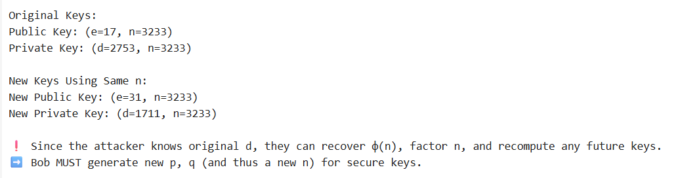

27. Write a C program for Bob uses the RSA cryptosystem with a very large modulus n for which the factorization cannot be found in a reasonable amount of time. Suppose Alice sends a message to Bob by representing each alphabetic character as an integer between 0 and 25 (A S 0, c, Z S 25) and then encrypting each number separately using RSA with large e and large n. Is this method secure? If not, describe the most efficient attack against this encryption method.

#include <stdio.h>

#include <math.h>

long long modExp(long long base, long long exp, long long mod) {

long long result = 1;

base = base % mod;

while (exp > 0) {

if (exp % 2 == 1) result = (result * base) % mod;

exp = exp >> 1;

base = (base * base) % mod;

}

return result;

}

int main() {

long long e = 17;

long long n = 3233;

int message = 2;

long long ciphertext = modExp(message, e, n);

printf("Encrypted 'C' (2): %lld\n", ciphertext);

printf("\nAttacker trying brute-force:\n");

for (int m = 0; m < 26; m++) {

long long test = modExp(m, e, n);

printf("Trying m = %2d → %4lld", m, test);

if (test == ciphertext)

printf(" ← Match! m = %d ('%c')\n", m, 'A' + m);

else

printf("\n");

}

return 0;

}

OUTPUT:

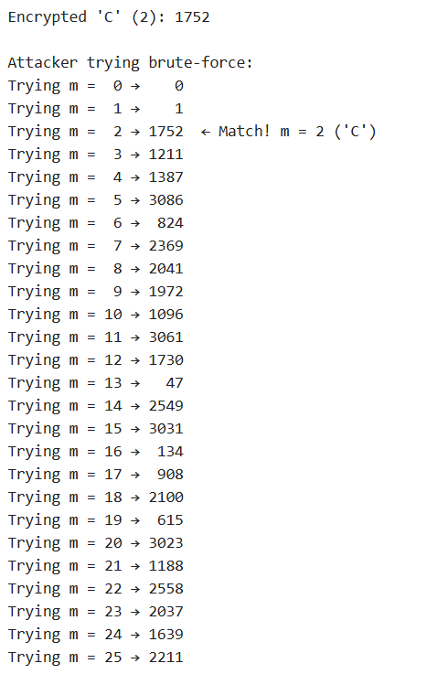

28. Write a C program for Diffie-Hellman protocol, each participant selects a secret number x and sends the other participant ax mod q for some public number a. What would happen if the participants sent each other xa for some public number a instead? Give at least one method Alice and Bob could use to agree on a key. Can Eve break your system without finding the secret numbers? Can Eve find the secret numbers?

#include <stdio.h>

#include <stdlib.h>

#include <time.h>

int modExp(int base, int exp, int mod) {

int result = 1;

base = base % mod;

while (exp > 0) {

if (exp % 2 == 1)

result = (result * base) % mod;

exp = exp >> 1;

base = (base * base) % mod;

}

return result;

}

int main() {

int q = 23;

int a = 5;

int x = 6;

int y = 15;

int A = modExp(a, x, q);

int B = modExp(a, y, q);

int K_alice = modExp(B, x, q);

int K_bob = modExp(A, y, q);

printf("Public values: a = %d, q = %d\n", a, q);

printf("Alice sends: %d\n", A);

printf("Bob sends: %d\n", B);

printf("Shared secret key computed by Alice: %d\n", K_alice);

printf("Shared secret key computed by Bob: %d\n", K_bob);

return 0;

}

OUTPUT:

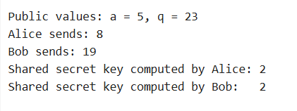

29. Write a C program for SHA-3 option with a block size of 1024 bits and assume that each of the lanes in the first message block (P0) has at least one nonzero bit. To start, all of the lanes in the internal state matrix that correspond to the capacity portion of the initial state are all zeros. Show how long it will take before all of these lanes have at least one nonzero bit. Note: Ignore the permutation. That is, keep track of the original zero lanes even after they have changed position in the matrix.

#include <stdio.h>

#include <stdlib.h>

#include <time.h>

#include <stdint.h>

#define TOTAL_LANES 25

#define RATE_LANES 16

#define CAPACITY_LANES 9

int all_capacity_filled(uint64_t* state) {

for (int i = RATE_LANES; i < TOTAL_LANES; i++) {

if (state[i] == 0) return 0;

}

return 1;

}

int main() {

uint64_t state[TOTAL_LANES] = {0};

srand(time(NULL));

for (int i = 0; i < RATE_LANES; i++) {

do {

state[i] = ((uint64_t)rand() << 32) | rand();

} while (state[i] == 0);

}

for (int i = RATE_LANES; i < TOTAL_LANES; i++) {

state[i] = 0;

}

int rounds = 0;

while (!all_capacity_filled(state)) {

uint64_t block[RATE_LANES];

for (int i = 0; i < RATE_LANES; i++) {

do {

block[i] = ((uint64_t)rand() << 32) | rand();

} while (block[i] == 0);

}

for (int i = 0; i < RATE_LANES; i++) {

state[i] ^= block[i];

}

int cap_index = RATE_LANES + rand() % CAPACITY_LANES;

state[cap_index] |= (1ULL << (rand() % 64));

rounds++;

}

printf("All capacity lanes filled with nonzero bits after %d rounds.\n", rounds);

return 0;

}

OUTPUT:



30. Write a C program for CBC MAC of a oneblock message X, say T = MAC(K, X), the adversary immediately knows the CBC MAC for the two-block message X || (X ⊕ T) since this is once again.

#include <stdio.h>

#include <stdint.h>

#include <string.h>

void block_cipher(uint8_t *block, uint8_t *key, uint8_t *out) {

for (int i = 0; i < 16; i++) {

out[i] = block[i] ^ key[i];

}

}

void cbc_mac(uint8_t *key, uint8_t *message, int blocks, uint8_t *mac_out) {

uint8_t prev[16] = {0};

uint8_t temp[16];

for (int b = 0; b < blocks; b++) {

for (int i = 0; i < 16; i++)

temp[i] = message[b * 16 + i] ^ prev[i];

block_cipher(temp, key, prev);

}

memcpy(mac_out, prev, 16);

}

void print_block(const char *label, uint8_t *b) {

printf("%s: ", label);

for (int i = 0; i < 16; i++) printf("%02X ", b[i]);

printf("\n");

}

int main() {

uint8_t key[16] = {0x0F};

uint8_t X[16] = {

0x10, 0x11, 0x12, 0x13,

0x14, 0x15, 0x16, 0x17,

0x18, 0x19, 0x1A, 0x1B,

0x1C, 0x1D, 0x1E, 0x1F

};

uint8_t T[16];

cbc_mac(key, X, 1, T);

print_block("CBC-MAC of X", T);

uint8_t second_block[16];

for (int i = 0; i < 16; i++)

second_block[i] = X[i] ^ T[i];

uint8_t two_block_msg[32];

memcpy(two_block_msg, X, 16);

memcpy(two_block_msg + 16, second_block, 16);

uint8_t T2[16];

cbc_mac(key, two_block_msg, 2, T2);

print_block("CBC-MAC of X || (X⊕T)", T2);

if (memcmp(T, T2, 16) == 0)

printf("\n⚠️ Vulnerability demonstrated: MAC(X) == MAC(X || (X⊕T))\n");

else

printf("\n✅ Secure (but shouldn't be in CBC-MAC without length fix)\n");

return 0;

}

OUTPUT:

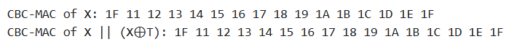

31. Write a C program for subkey generation in CMAC, it states that the block cipher is applied to the block that consists entirely of 0 bits. The first subkey is derived from the resulting string by a left shift of one bit and, conditionally, by XORing a constant that depends on the block size. The second subkey is derived in the same manner from the first subkey. a. What constants are needed for block sizes of 64 and 128 bits? b. How the left shift and XOR accomplishes the desired result.

#include <stdio.h>

#include <stdint.h>

#include <string.h>

#define BLOCK_SIZE 128

#define BYTE_LEN (BLOCK_SIZE / 8)

const uint8_t Rb_128 = 0x87;

void dummy_encrypt_zeros(const uint8_t* key, uint8_t* out) {

for (int i = 0; i < BYTE_LEN; i++) {

out[i] = i + 1;

}

}

void left_shift_1bit(uint8_t* input, uint8_t* output) {

uint8_t carry = 0;

for (int i = BYTE_LEN - 1; i >= 0; i--) {

output[i] = (input[i] << 1) | carry;

carry = (input[i] & 0x80) ? 1 : 0;

}

}

void xor_rb(uint8_t* block) {

block[BYTE_LEN - 1] ^= Rb_128;

}

void print_block(const char* label, uint8_t* block) {

printf("%s: ", label);

for (int i = 0; i < BYTE_LEN; i++) {

printf("%02X ", block[i]);

}

printf("\n");

}

int main() {

uint8_t key[BYTE_LEN] = {0};

uint8_t L[BYTE_LEN];

uint8_t K1[BYTE_LEN];

uint8_t K2[BYTE_LEN];

dummy_encrypt_zeros(key, L);

print_block("L", L);

left_shift_1bit(L, K1);

if (L[0] & 0x80) xor_rb(K1);

print_block("K1", K1);

left_shift_1bit(K1, K2);

if (K1[0] & 0x80) xor_rb(K2);

print_block("K2", K2);

return 0;

}

OUTPUT:

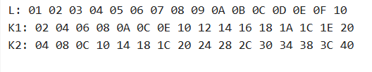

32. Write a C program for DSA, because the value of k is generated for each signature, even if the same message is signed twice on different occasions, the signatures will differ. This is not true of RSA signatures. Write a C program for implication of this difference?

#include <stdio.h>

#include <stdlib.h>

#include <string.h>

#include <time.h>

unsigned int hash_message(const char* msg) {

unsigned int hash = 0;

for (int i = 0; msg[i]; i++)

hash = (hash * 31 + msg[i]) % 10007;

return hash;

}

unsigned int rsa_sign(const char* msg, unsigned int d, unsigned int n) {

unsigned int h = hash_message(msg);

unsigned int sig = 1;

for (int i = 0; i < d; i++)

sig = (sig * h) % n;

return sig;

}

unsigned int dsa_sign(const char* msg, unsigned int private_key, unsigned int q) {

unsigned int h = hash_message(msg);

unsigned int k = rand() % (q - 1) + 1;

unsigned int sig = (h * k + private_key) % q;

return sig;

}

int main() {

srand(time(NULL));

const char* message = "SecureMessage";

unsigned int rsa_n = 3233;

unsigned int rsa_d = 17;

unsigned int dsa_private = 23;

unsigned int dsa_q = 101;

printf("Message: \"%s\"\n\n", message);

unsigned int rsa_sig1 = rsa_sign(message, rsa_d, rsa_n);

unsigned int rsa_sig2 = rsa_sign(message, rsa_d, rsa_n);

printf("RSA Signatures:\n");

printf("Signature 1: %u\n", rsa_sig1);

printf("Signature 2: %u\n", rsa_sig2);

printf("✅ RSA produces same signature for same message.\n\n");

unsigned int dsa_sig1 = dsa_sign(message, dsa_private, dsa_q);

unsigned int dsa_sig2 = dsa_sign(message, dsa_private, dsa_q);

printf("DSA Signatures:\n");

printf("Signature 1: %u\n", dsa_sig1);

printf("Signature 2: %u\n", dsa_sig2);

if (dsa_sig1 != dsa_sig2)

printf("✅ DSA produces different signatures due to random nonce k.\n");

else

printf("⚠️ Unexpected result — signatures matched (rare).\n");

return 0;

}

OUTPUT:

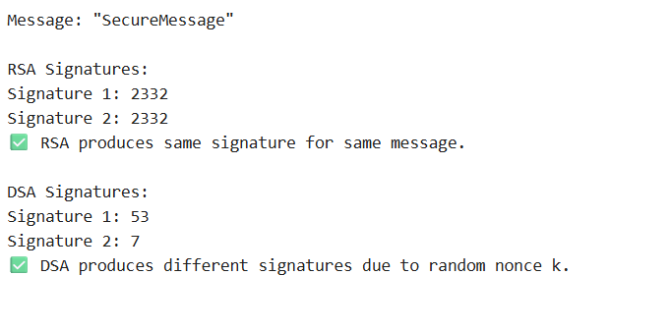

33. Write a C program for Data encryption standard (DES) has been found vulnerable to very powerful attacks and therefore, the popularity of DES has been found slightly on the decline. DES is a block cipher and encrypts data in blocks of size of 64 bits each, which means 64 bits of plain text go as the input to DES, which produces 64 bits of ciphertext. The same algorithm and key are used for encryption and decryption, with minor differences. The key length is 56 bits. Implement in C programming.

#include <stdio.h>

#include <stdint.h>

#include <string.h>

int IP[] = {

58, 50, 42, 34, 26, 18, 10, 2,

60, 52, 44, 36, 28, 20, 12, 4,

62, 54, 46, 38, 30, 22, 14, 6,

64, 56, 48, 40, 32, 24, 16, 8,

57, 49, 41, 33, 25, 17, 9, 1,

59, 51, 43, 35, 27, 19, 11, 3,

61, 53, 45, 37, 29, 21, 13, 5,

63, 55, 47, 39, 31, 23, 15, 7

};

int FP[] = {

40, 8, 48, 16, 56, 24, 64, 32,

39, 7, 47, 15, 55, 23, 63, 31,

38, 6, 46, 14, 54, 22, 62, 30,

37, 5, 45, 13, 53, 21, 61, 29,

36, 4, 44, 12, 52, 20, 60, 28,

35, 3, 43, 11, 51, 19, 59, 27,

34, 2, 42, 10, 50, 18, 58, 26,

33, 1, 41, 9, 49, 17, 57, 25

};

uint64_t key = 0x133457799BBCDFF1;

uint32_t feistel(uint32_t half, uint64_t subkey) {

return (half ^ (subkey & 0xFFFFFFFF));

}

uint64_t permute(uint64_t input, const int* table, int n) {

uint64_t output = 0;

for (int i = 0; i < n; i++) {

output <<= 1;

output |= (input >> (64 - table[i])) & 0x01;

}

return output;

}

uint64_t des_process(uint64_t block, int encrypt) {

uint64_t permuted = permute(block, IP, 64);

uint32_t L = (permuted >> 32) & 0xFFFFFFFF;

uint32_t R = permuted & 0xFFFFFFFF;

for (int round = 0; round < 16; round++) {

uint64_t subkey = key >> (encrypt ? round : 15 - round);

uint32_t temp = R;

R = L ^ feistel(R, subkey);

L = temp;

}

uint64_t preoutput = ((uint64_t)R << 32) | L;

return permute(preoutput, FP, 64);

}

uint64_t str_to_uint64(const char* str) {

uint64_t val = 0;

for (int i = 0; i < 8; i++) {

val = (val << 8) | (unsigned char)str[i];

}

return val;

}

void uint64_to_str(uint64_t val, char* str) {

for (int i = 7; i >= 0; i--) {

str[i] = val & 0xFF;

val >>= 8;

}

str[8] = '\0';

}

int main() {

char plaintext[9] = "DESDEMO!";

char decrypted[9];

uint64_t pt = str_to_uint64(plaintext);

printf("Plaintext: %s\n", plaintext);

uint64_t ct = des_process(pt, 1);

printf("Encrypted (hex): %016llX\n", ct);

uint64_t dt = des_process(ct, 0);

uint64_to_str(dt, decrypted);

printf("Decrypted: %s\n", decrypted);

return 0;

}

OUTPUT:

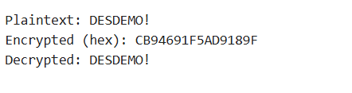

34. Write a C program for ECB, CBC, and CFB modes, the plaintext must be a sequence of one or more complete data blocks (or, for CFB mode, data segments). In other words, for these three modes, the total number of bits in the plaintext must be a positive multiple of the block (or segment) size. One common method of padding, if needed, consists of a 1 bit followed by as few zero bits, possibly none, as are necessary to complete the final block. It is considered good practice for the sender to pad every message, including messages in which the final message block is already complete. What is the motivation for including a padding block when padding is not needed?

#include <stdio.h>

#include <stdint.h>

#include <string.h>

#define BLOCK_SIZE 8

void xor_cipher(uint8_t *input, uint8_t *key, uint8_t *output) {

for (int i = 0; i < BLOCK_SIZE; i++) {

output[i] = input[i] ^ key[i];

}

}

int add_padding(uint8_t *data, int len) {

int pad_len = BLOCK_SIZE - (len % BLOCK_SIZE);

data[len] = 0x80;

for (int i = 1; i < pad_len; i++)

data[len + i] = 0x00;

return len + pad_len;

}

void ecb_encrypt(uint8_t *data, int len, uint8_t *key, uint8_t *output) {

for (int i = 0; i < len; i += BLOCK_SIZE)

xor_cipher(data + i, key, output + i);

}

void cbc_encrypt(uint8_t *data, int len, uint8_t *key, uint8_t *iv, uint8_t *output) {

uint8_t temp[BLOCK_SIZE];

for (int i = 0; i < len; i += BLOCK_SIZE) {

for (int j = 0; j < BLOCK_SIZE; j++)

temp[j] = data[i + j] ^ iv[j];

xor_cipher(temp, key, output + i);

memcpy(iv, output + i, BLOCK_SIZE);

}

}

void cfb_encrypt(uint8_t *data, int len, uint8_t *key, uint8_t *iv, uint8_t *output) {

uint8_t cipher_out[BLOCK_SIZE];

for (int i = 0; i < len; i += BLOCK_SIZE) {

xor_cipher(iv, key, cipher_out);

for (int j = 0; j < BLOCK_SIZE; j++)

output[i + j] = data[i + j] ^ cipher_out[j];

memcpy(iv, output + i, BLOCK_SIZE);

}

}

void print_hex(const char *label, uint8_t *data, int len) {

printf("%s: ", label);

for (int i = 0; i < len; i++)

printf("%02X ", data[i]);

printf("\n");

}

int main() {

uint8_t key[BLOCK_SIZE] = {0x1A, 0x2B, 0x3C, 0x4D, 0x5E, 0x6F, 0x70, 0x81};

uint8_t iv1[BLOCK_SIZE] = {0x00};

uint8_t iv2[BLOCK_SIZE] = {0x00};

uint8_t iv3[BLOCK_SIZE] = {0x00};

char message[] = "HELLO BLOCK WORLD!";

uint8_t data[64];

memset(data, 0, sizeof(data));

memcpy(data, message, strlen(message));

int padded_len = add_padding(data, strlen(message));

uint8_t ecb_out[64], cbc_out[64], cfb_out[64];

memset(ecb_out, 0, 64);

memset(cbc_out, 0, 64);

memset(cfb_out, 0, 64);

ecb_encrypt(data, padded_len, key, ecb_out);

cbc_encrypt(data, padded_len, key, iv1, cbc_out);

cfb_encrypt(data, padded_len, key, iv2, cfb_out);

print_hex("Plaintext", data, padded_len);

print_hex("ECB Cipher", ecb_out, padded_len);

print_hex("CBC Cipher", cbc_out, padded_len);

print_hex("CFB Cipher", cfb_out, padded_len);

return 0;

}

OUTPUT:

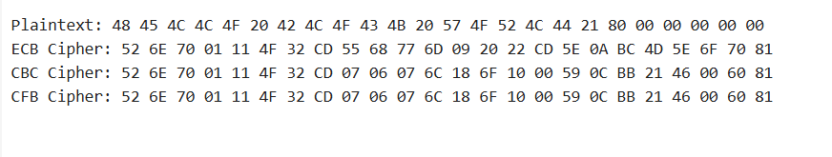

35. Write a C program for one-time pad version of the Vigenère cipher. In this scheme, the key is a stream of random numbers between 0 and 26. For example, if the key is 3 19 5 . . . , then the first letter of plaintext is encrypted with a shift of 3 letters, the second with a shift of 19 letters, the third with a shift of 5 letters, and so on.

#include <stdio.h>

#include <stdlib.h>

#include <time.h>

#include <ctype.h>

#include <string.h>

#define MAX_LEN 1024

char encrypt_char(char c, int key) {

if (isupper(c)) {

return 'A' + (c - 'A' + key) % 26;

} else if (islower(c)) {

return 'a' + (c - 'a' + key) % 26;

}

return c;

}

char decrypt_char(char c, int key) {

if (isupper(c)) {

return 'A' + (c - 'A' - key + 26) % 26;

} else if (islower(c)) {

return 'a' + (c - 'a' - key + 26) % 26;

}

return c;

}

int main() {

char plaintext[MAX_LEN];

char ciphertext[MAX_LEN];

char decrypted[MAX_LEN];

int key[MAX_LEN];

printf("Enter plaintext (letters only): ");

fgets(plaintext, sizeof(plaintext), stdin);

plaintext[strcspn(plaintext, "\n")] = '\0';

srand(time(NULL));

int len = strlen(plaintext);

for (int i = 0; i < len; i++) {

if (isalpha(plaintext[i])) {

key[i] = rand() % 27;

ciphertext[i] = encrypt_char(plaintext[i], key[i]);

} else {

key[i] = 0;

ciphertext[i] = plaintext[i];

}

}

ciphertext[len] = '\0';

for (int i = 0; i < len; i++) {

decrypted[i] = decrypt_char(ciphertext[i], key[i]);

}

decrypted[len] = '\0';

printf("\nGenerated key: ");

for (int i = 0; i < len; i++) {

if (isalpha(plaintext[i]))

printf("%d ", key[i]);

else

printf("_ ");

}

printf("\nCiphertext: %s", ciphertext);

printf("\nDecrypted : %s\n", decrypted);

return 0;

}

OUTPUT:

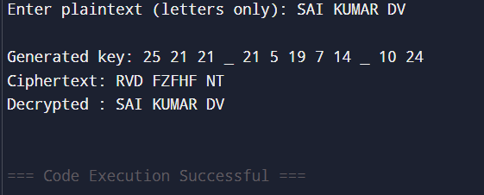

36. Write a C program for Caesar cipher, known as the affine Caesar cipher, has the following form: For each plaintext letter p, substitute the ciphertext letter C: C = E([a, b], p) = (ap + b) mod 26 A basic requirement of any encryption algorithm is that it be one-to-one. That is, if p q, then E(k, p) E(k, q). Otherwise, decryption is impossible, because more than one plaintext character maps into the same ciphertext character. The affine Caesar cipher is not one-to-one for all values of a. For example, for a = 2 and b = 3, then E([a, b], 0) = E([a, b], 13) = 3.

#include <stdio.h>

#include <string.h>

#include <ctype.h>

int gcd(int a, int b) {

while (b != 0) {

int temp = b;

b = a % b;

a = temp;

}

return a;

}

int modInverse(int a, int m) {

a = a % m;

for (int x = 1; x < m; x++) {

if ((a * x) % m == 1)

return x;

}

return -1;

}

char encryptChar(char ch, int a, int b) {

if (isalpha(ch)) {

ch = toupper(ch);

int p = ch - 'A';

int c = (a * p + b) % 26;

return c + 'A';

}

return ch;

}

char decryptChar(char ch, int a, int b) {

if (isalpha(ch)) {

ch = toupper(ch);

int a_inv = modInverse(a, 26);

if (a_inv == -1) return '?';

int c = ch - 'A';

int p = (a_inv * (c - b + 26)) % 26;

return p + 'A';

}

return ch;

}

int main() {

char plaintext[100], ciphertext[100], decrypted[100];

int a, b;

printf("Enter values of a and b (a must be coprime with 26): ");

scanf("%d %d", &a, &b);

if (gcd(a, 26) != 1) {

printf("Invalid 'a' value! It must be coprime with 26.\n");

return 1;

}

printf("Enter the plaintext (letters only, no special characters): ");

scanf(" %[^\n]", plaintext);

int len = strlen(plaintext);

for (int i = 0; i < len; i++) {

ciphertext[i] = encryptChar(plaintext[i], a, b);

}

ciphertext[len] = '\0';

printf("Encrypted Text: %s\n", ciphertext);

for (int i = 0; i < len; i++) {

decrypted[i] = decryptChar(ciphertext[i], a, b);

}

decrypted[len] = '\0';

printf("Decrypted Text: %s\n", decrypted);

return 0;

}

OUTPUT:

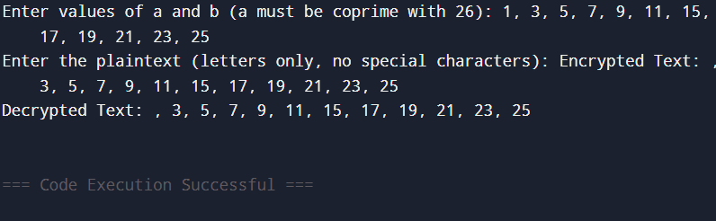

37. Write a C program that can perform a letter frequency attack on any monoalphabetic substitution cipher without human intervention. Your software should produce possible plaintexts in rough order of likelihood. It would be good if your user interface allowed the user to specify “give me the top 10 possible plaintexts.”

#include <stdio.h>

#include <string.h>

#include <stdlib.h>

#include <ctype.h>

#define ALPHABET_SIZE 26

#define MAX_TEXT_LEN 1000

#define MAX_RESULTS 10

const char *englishFreq = "ETAOINSHRDLCUMWFGYPBVKJXQZ";

typedef struct {

char letter;

int count;

} Frequency;

int compareFreq(const void *a, const void *b) {

return ((Frequency *)b)->count - ((Frequency *)a)->count;

}

void analyzeFrequency(const char *text, Frequency freq[]) {

for (int i = 0; i < ALPHABET_SIZE; i++) {

freq[i].letter = 'A' + i;

freq[i].count = 0;

}

for (int i = 0; text[i] != '\0'; i++) {

if (isalpha(text[i])) {

char ch = toupper(text[i]);

freq[ch - 'A'].count++;

}

}

qsort(freq, ALPHABET_SIZE, sizeof(Frequency), compareFreq);

}

void generateMapping(Frequency freq[], char map[26], int offset) {

for (int i = 0; i < ALPHABET_SIZE; i++) {

if (i + offset < ALPHABET_SIZE) {

map[freq[i].letter - 'A'] = englishFreq[i + offset];

} else {

map[freq[i].letter - 'A'] = freq[i].letter;

}

}

}

void applyMapping(const char *cipher, char *output, char map[26]) {

for (int i = 0; cipher[i] != '\0'; i++) {

if (isalpha(cipher[i])) {

char upper = toupper(cipher[i]);

char subst = map[upper - 'A'];

output[i] = islower(cipher[i]) ? tolower(subst) : subst;

} else {

output[i] = cipher[i];

}

}

output[strlen(cipher)] = '\0';

}

int main() {

char ciphertext[MAX_TEXT_LEN];

int topN;

printf("Enter the ciphertext (uppercase or lowercase letters only):\n");

scanf(" %[^\n]", ciphertext);

printf("Enter number of top possible plaintexts to display: ");

scanf("%d", &topN);

if (topN > MAX_RESULTS) topN = MAX_RESULTS;

Frequency freq[ALPHABET_SIZE];

char plaintext[MAX_TEXT_LEN];

char map[26];

analyzeFrequency(ciphertext, freq);

printf("\nTop %d possible plaintexts:\n", topN);

for (int i = 0; i < topN; i++) {

generateMapping(freq, map, i);

applyMapping(ciphertext, plaintext, map);

printf("\nOption %d:\n%s\n", i + 1, plaintext);

}

return 0;

}

OUTPUT:

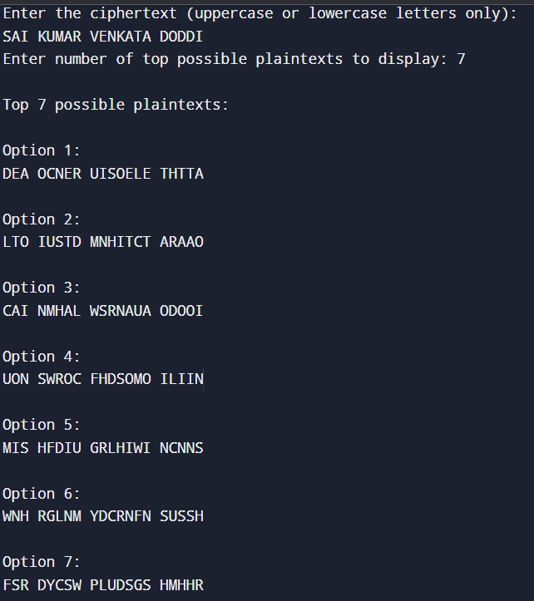

38. Write a C program for Hill cipher succumbs to a known plaintext attack if sufficient plaintext ciphertext pairs are provided. It is even easier to solve the Hill cipher if a chosen plaintext attack can be mounted. Implement in C programming.

#include <stdio.h>

#include <string.h>

#define MOD 26

int modInverse(int a, int m) {

a = a % m;

for (int x = 1; x < m; x++)

if ((a * x) % m == 1)

return x;

return -1;

}

int determinant(int matrix[2][2]) {

return (matrix[0][0] * matrix[1][1] - matrix[0][1] * matrix[1][0]) % MOD;

}

int inverseMatrix(int matrix[2][2], int inv[2][2]) {

int det = determinant(matrix);

det = (det + MOD) % MOD;

int detInv = modInverse(det, MOD);

if (detInv == -1) return 0;

inv[0][0] = matrix[1][1] * detInv % MOD;

inv[0][1] = -matrix[0][1] * detInv % MOD;

inv[1][0] = -matrix[1][0] * detInv % MOD;

inv[1][1] = matrix[0][0] * detInv % MOD;

for (int i = 0; i < 2; i++)

for (int j = 0; j < 2; j++)

if (inv[i][j] < 0)

inv[i][j] += MOD;

return 1;

}

void multiplyMatrix(int a[2][2], int b[2][2], int result[2][2]) {

for (int i = 0; i < 2; i++)

for (int j = 0; j < 2; j++) {

result[i][j] = 0;

for (int k = 0; k < 2; k++)

result[i][j] += a[i][k] * b[k][j];

result[i][j] %= MOD;

}

}

void textToMatrix(char *text, int matrix[2][2]) {

for (int i = 0; i < 4; i++) {

text[i] = toupper(text[i]);

matrix[i / 2][i % 2] = text[i] - 'A';

}

}

void encrypt(char *pt, char *ct, int key[2][2]) {

int p[2];

for (int i = 0; i < 2; i++)

p[i] = toupper(pt[i]) - 'A';

for (int i = 0; i < 2; i++) {

int val = 0;

for (int j = 0; j < 2; j++)

val += key[i][j] * p[j];

ct[i] = (val % MOD) + 'A';

}

ct[2] = '\0';

}

int main() {

char plaintext[] = "HELP";

char ciphertext[] = "IZWX";

int P[2][2], C[2][2], P_inv[2][2], Key[2][2];

textToMatrix(plaintext, P);

textToMatrix(ciphertext, C);

printf("Known plaintext matrix:\n");

printf("%d %d\n%d %d\n", P[0][0], P[0][1], P[1][0], P[1][1]);

printf("Known ciphertext matrix:\n");

printf("%d %d\n%d %d\n", C[0][0], C[0][1], C[1][0], C[1][1]);

if (!inverseMatrix(P, P_inv)) {

printf("Matrix inversion failed. Plaintext matrix is not invertible mod 26.\n");

return 1;

}

multiplyMatrix(C, P_inv, Key);

printf("Recovered Key Matrix:\n");

printf("%d %d\n%d %d\n", Key[0][0], Key[0][1], Key[1][0], Key[1][1]);

char test[] = "HI";

char encrypted[3];

encrypt(test, encrypted, Key);

printf("Test Encryption of '%s': %s\n", test, encrypted);

return 0;

}

OUTPUT:

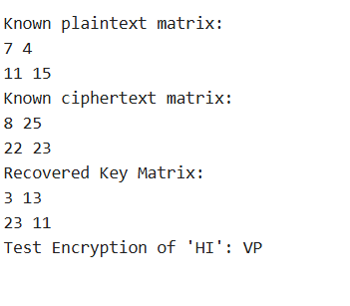

39. Write a C program that can perform a letter frequency attack on an additive cipher without human intervention. Your software should produce possible plaintexts in rough order of likelihood. It would be good if your user interface allowed the user to specify “give me the top 10 possible plaintexts.”

#include <stdio.h>

#include <string.h>

#include <ctype.h>

#include <stdlib.h>

#define MAX_LEN 1000

#define ALPHABET_SIZE 26

const char *english_order = "ETAOINSHRDLCUMWFGYPBVKJXQZ";

typedef struct {

int key;

int score;

char plaintext[MAX_LEN];

} Candidate;

void decrypt(char *cipher, char *plain, int key) {

for (int i = 0; cipher[i] != '\0'; i++) {

char c = cipher[i];

if (isalpha(c)) {

char base = isupper(c) ? 'A' : 'a';

plain[i] = (c - base - key + 26) % 26 + base;

} else {

plain[i] = c;

}

}

plain[strlen(cipher)] = '\0';

}

int scoreText(char *text) {

int freq[ALPHABET_SIZE] = {0};

for (int i = 0; text[i]; i++) {

if (isalpha(text[i])) {

freq[toupper(text[i]) - 'A']++;

}

}

int score = 0;

for (int i = 0; i < ALPHABET_SIZE; i++) {

char ch = english_order[i];

score += freq[ch - 'A'] * (ALPHABET_SIZE - i);

}

return score;

}

int compare(const void *a, const void *b) {

return ((Candidate *)b)->score - ((Candidate *)a)->score;

}

int main() {

char ciphertext[MAX_LEN];

int n;

printf("Enter the ciphertext:\n");

scanf(" %[^\n]", ciphertext);

printf("Enter how many top guesses to show (max 26): ");

scanf("%d", &n);

if (n > 26) n = 26;

Candidate candidates[26];

for (int key = 0; key < 26; key++) {

decrypt(ciphertext, candidates[key].plaintext, key);

candidates[key].key = key;

candidates[key].score = scoreText(candidates[key].plaintext);

}

qsort(candidates, 26, sizeof(Candidate), compare);

printf("\nTop %d possible plaintexts:\n", n);

for (int i = 0; i < n; i++) {

printf("Option %d (Key = %d):\n%s\n\n", i + 1, candidates[i].key, candidates[i].plaintext);

}

return 0;

}

OUTPUT:

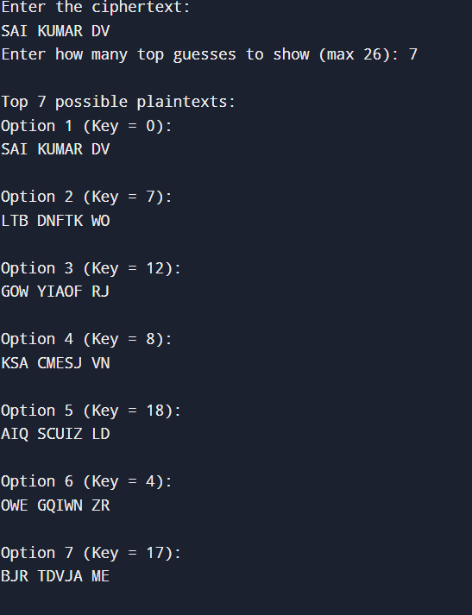

40. Write a C program that can perform a letter frequency attack on any monoalphabetic substitution cipher without human intervention. Your software should produce possible plaintexts in rough order of likelihood. It would be good if your user interface allowed the user to specify “give me the top 10 possible plaintexts.”

#include <stdio.h>

#include <string.h>

#include <stdlib.h>

#include <ctype.h>

#define MAX_TEXT 1000

#define MAX_RESULTS 10

#define ALPHABET_SIZE 26

const char *english_order = "ETAOINSHRDLCUMWFGYPBVKJXQZ";

typedef struct {

char letter;

int count;

} Frequency;

int compareFreq(const void *a, const void *b) {

return ((Frequency *)b)->count - ((Frequency *)a)->count;

}

void countFrequencies(char *text, Frequency freq[]) {

for (int i = 0; i < ALPHABET_SIZE; i++) {

freq[i].letter = 'A' + i;

freq[i].count = 0;

}

for (int i = 0; text[i]; i++) {

if (isalpha(text[i])) {

char ch = toupper(text[i]);

freq[ch - 'A'].count++;

}

}

qsort(freq, ALPHABET_SIZE, sizeof(Frequency), compareFreq);

}

void buildMapping(Frequency freq[], char map[26], int shift) {

for (int i = 0; i < ALPHABET_SIZE; i++) {

if (i + shift < ALPHABET_SIZE) {

map[freq[i].letter - 'A'] = english_order[i + shift];

} else {

map[freq[i].letter - 'A'] = freq[i].letter;

}

}

}

void applyMapping(char *ciphertext, char *plaintext, char map[26]) {

for (int i = 0; ciphertext[i]; i++) {

if (isalpha(ciphertext[i])) {

char ch = toupper(ciphertext[i]);

char mapped = map[ch - 'A'];

plaintext[i] = islower(ciphertext[i]) ? tolower(mapped) : mapped;

} else {

plaintext[i] = ciphertext[i];

}

}

plaintext[strlen(ciphertext)] = '\0';

}

int main() {

char ciphertext[MAX_TEXT];

int topN;

printf("Enter the ciphertext (monoalphabetic cipher):\n");

scanf(" %[^\n]", ciphertext);

printf("Enter the number of top guesses to show (max 10): ");

scanf("%d", &topN);

if (topN > MAX_RESULTS) topN = MAX_RESULTS;

Frequency freq[ALPHABET_SIZE];

char plaintext[MAX_TEXT];

char map[26];

countFrequencies(ciphertext, freq);

printf("\nTop %d possible plaintexts (based on frequency analysis):\n", topN);

for (int i = 0; i < topN; i++) {

buildMapping(freq, map, i);

applyMapping(ciphertext, plaintext, map);

printf("\nOption %d:\n%s\n", i + 1, plaintext);

}

return 0;

}

OUTPUT:

